2024 Show Dates:
Friday, February, 23rd
Saturday, February, 24th
Sunday, February, 25th
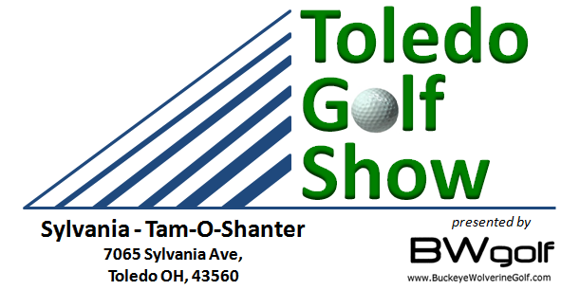
2024 Toledo Golf Show Early-Bird Registration Form
(This form & the FULL Payment must be received by October 1st 2023 to be eligible for the Early Bird Discount)

Vendor / Course Name: ____________________________ Email: ____________________________________

Address: __________________________________________________________________________________

Phone: ______________________________ Contact Name: _________________________________________

Exhibit Space: Each space includes (1) 8’ table covered and skirted, (2) chairs, and (2) exhibitor badges. Spaces will be approximately 10’ long by 10’ deep with Pipe & Drapes. Some spaces may vary slightly. Electricity is available at an additional charge. If you elect to use electricity, please bring your own 50-foot extension cord. FREE Internet WiFi is available.
Early Bird Pricing
Stamp Card Sponsor $125.00 $________________
Exhibit Space $500.00 $________________
Electricity $25.00 $________________
Total: $________________

Note: Call (734) 807-0262 for Oversize or Multiple Space Pricing.

Booths will be assigned on a first come first serve basis. List your 1st , 2nd and 3rd choices:
1st: _______ 2nd: ______ 3rd: ______ See floor plan on our web site www.ToledoGolfShow.com

I have read, agree with, and will abide by all Rules & Regulations put forth by BW Golf LLC and the facility Rules are posted on our web site www.ToledoGolfShow.com

Signature:__________________________________________Date:____________________________

FULL Payment Due when reserving exhibit space.

For Credit Card Payments:

Card Number: ___________________________________

Exp. Date: __________ 3-Digit Security Code:__________

Zip Code: __________________

Signature: _____________________________________

Make Checks payable to: BW Golf LLC
Mail Registration form and check to
BW Golf LLC
5630 Sylvania- Petersburg Rd
Petersburg, MI 49270

